TITLE OF PORTFOLIO

A Masters Portfolio
Submitted to
<Committee Chairperson>
<Committee Member>
<Committee Member>
and The Department of Religious Studies at
Missouri State University

TEMPLATE

In Partial Fulfillment
Of the Requirements for the Degree
Master of Arts, Religious Studies

By
<Name>
<month/year of graduation, e.g., May 2018>
TITLE OF PORTFOLIO
Department of Religious Studies
Missouri State University, <month year, e.g., May 2018>
Master of Arts
<Name>

CONTENTS PAGE
1. INTRODUCTION/REFLECTION 1

2. TITLE OF FIRST PAPER 5

3. TITLE OF SECOND PAPER 43

ACKNOWLEDGEMENTS

If desired, a page can be inserted for the purpose of acknowledging the assistance and support of others. If used, it should be clearly delineated. Single spacing is acceptable if necessary to keep this all on one page.
I would like to thank the following people for their support during the course of my graduate studies.
A dedication can be included as well. It should be separated from the rest of the acknowledgement. The following is an example.

I dedicate this thesis to (insert person to be dedicated here).

INTRODUCTION/REFLECTION

This is where you introduce your portfolio, background information, reasons for your research, or similar information to state an overall theme or purpose.

Page Numbering
Page numbers: centered 1/2" from bottom of each page. The title page is counted as “i” although the pagination is not shown. Additional pages prior to the body of the papers should be numbered with small Roman numerals; the body of the two papers (including the Reference section of each paper), should be consecutively numbered (i.e., do not begin new numbering with the second paper), with Arabic numerals.

Spacing
Page margins are to be 1" on top, bottom, and right side; 1.5" margin on left side. Use 12-point Times New Roman font, left-justified, and double space the body of the text. Indent paragraphs 1/2" and do not double-space between paragraphs. Single spacing is required for footnotes or quotations of five lines or more, and may be used for table headings and figure captions. In addition, single spacing is acceptable in the Acknowledgement Page if this enables these sections to be one page. References (Bibliography) may be single spaced within the reference and double spaced between references. Consult the style manual approved by the faculty in your program for appropriate reference format.

Headings
Headings should be descriptive, focus attention on distinctive sections, and thus enable a quick targeting of salient information addressed in the papers. Depending on the nature of the subject, more than one level of heading may be appropriate. Be consistent in placement and other aspects of formatting headings that divide the text. Consult the style manual approved by the faculty in your program for appropriate format for headings and other stylistic requirements for your papers.

Citations
Every reference cited in the text should be listed in the Reference (Bibliography) section that follows the main body of each paper. Consistency is key; consult the style manual approved by the faculty in your program for appropriate format for footnotes and references.

Final Portfolio Submission
After passing your Portfolio Defense with your committee, bring your signed Seminar Report Form (see below) to the Religious Studies Department’s Administrative Assistant to make one copy for your file and to send the original to the Graduate College.
Remove the “TEMPLATE” watermark from your portfolio before printing. In Word, on the Design tab, at Watermark section, select Remove Watermark.
Print your portfolio, including title page, etc., on archival paper (25% cotton), single-sided, and have one copy bound (see below), for the Religious Studies Department’s library.
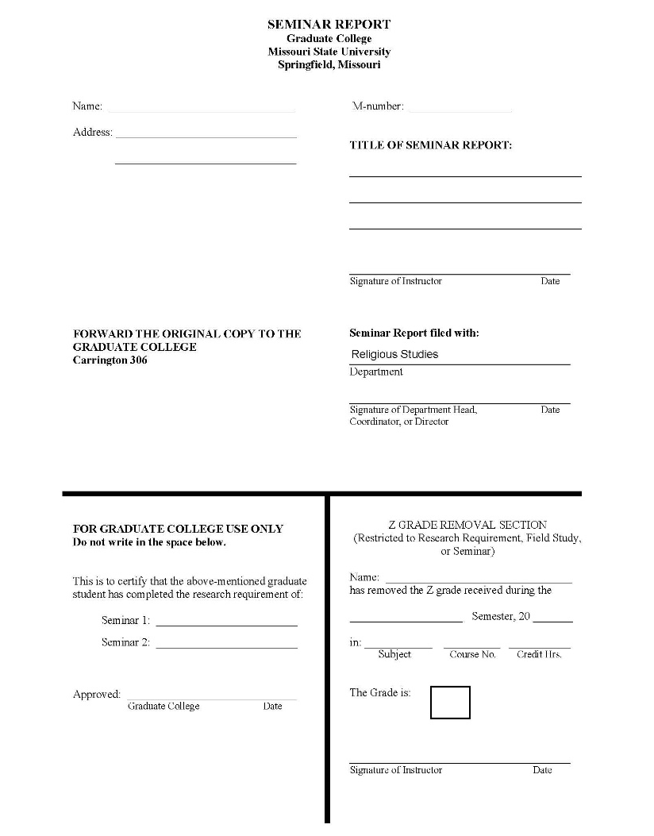
Example of Seminar Report Form (above)
Example of CombBound Portfolio (above)

